create database pharma;

use pharma;

create table medAddDept(ref varchar(15), medName(15));

create table medInfo(ref varchar(15), comName varchar(15), medType varchar(15), medName varchar(15), lotNo varchar(15), issueDate varchar(15), expDate varchar(15), uses varchar(15), sideEff varchar(15), precWar varchar(15), dosage varchar(15), tabPrice varchar(15));

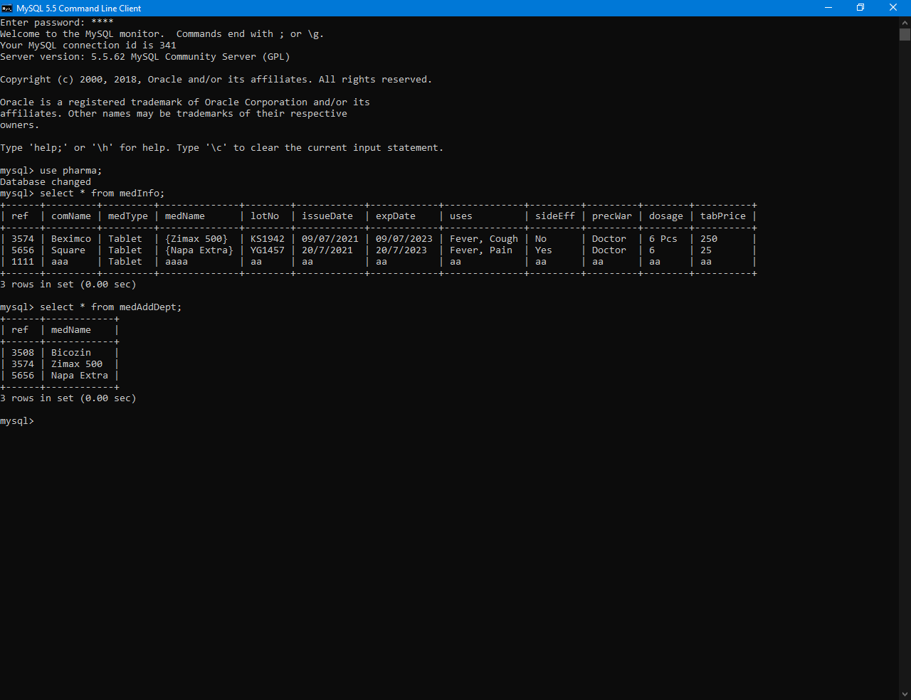

select \* from medAddDept;

select \* from medInfo;